|  |  |
| --- | --- |
| Critical Information Summary | |
| Student Name | Yuan Ren , Dingan Ma |
| SID | 215194192,216328682 |
| Mark Aimed For (%) | 90 |

### Criteria: Playability [HD]

1. Our game is developed by unity, so it was more engaged.
2. Our game can be played by 10 hour and compare to our classmates’ game, our game was more interesting.

### Criteria: Layout [HD]

1. [p] Your app works in portrait phone mode.

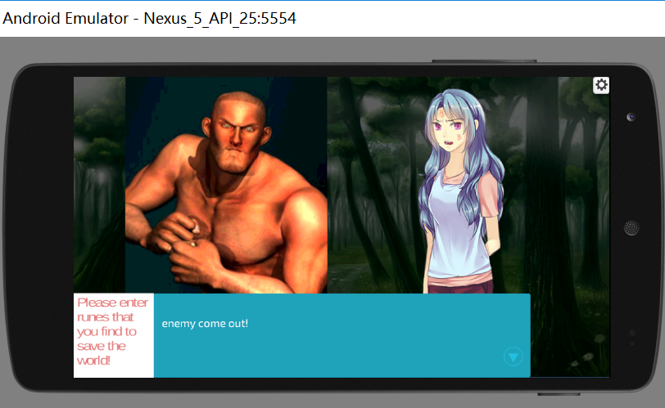

1. [c] Your app works in both portrait phone, tablet portrait, and tablet landscape mode.

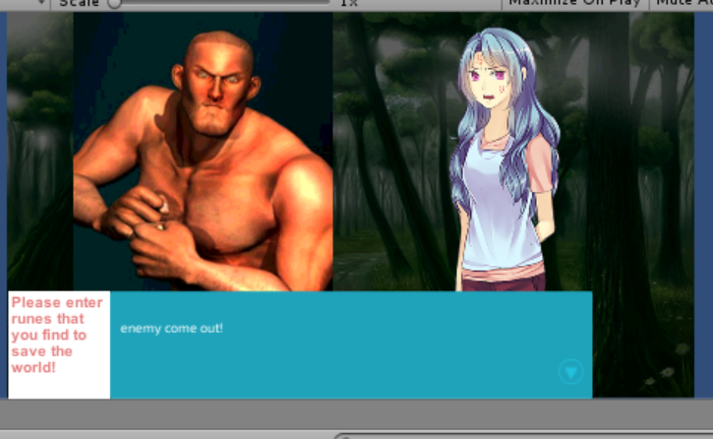

1. [hd] Your app dynamically adjusts in real-time to changes in orientation & resolution.

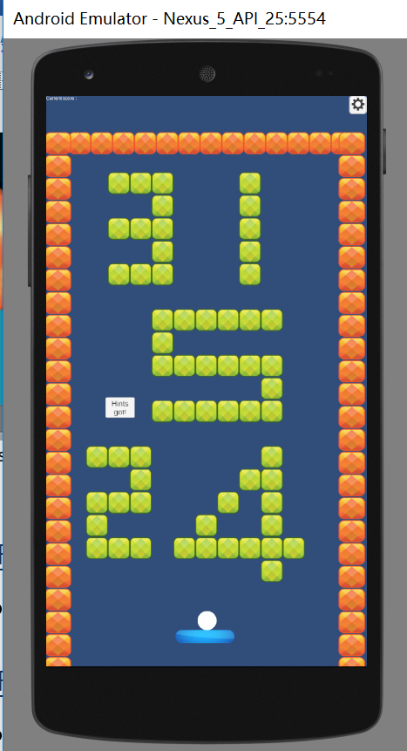

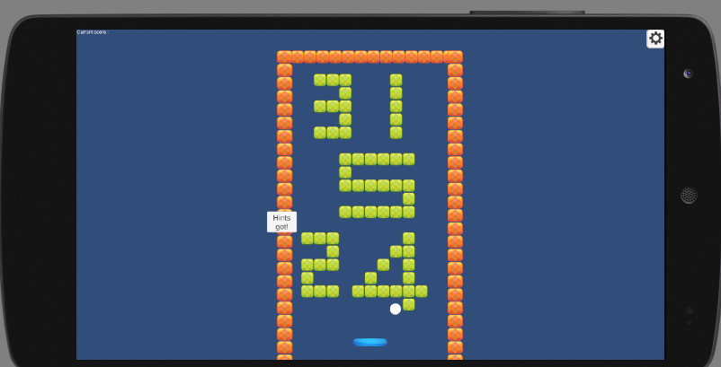

### Criteria: Readme [HD]

1. [P]Includes your name, app title, app platform, link to github/bitbucket, and an overview of your app.

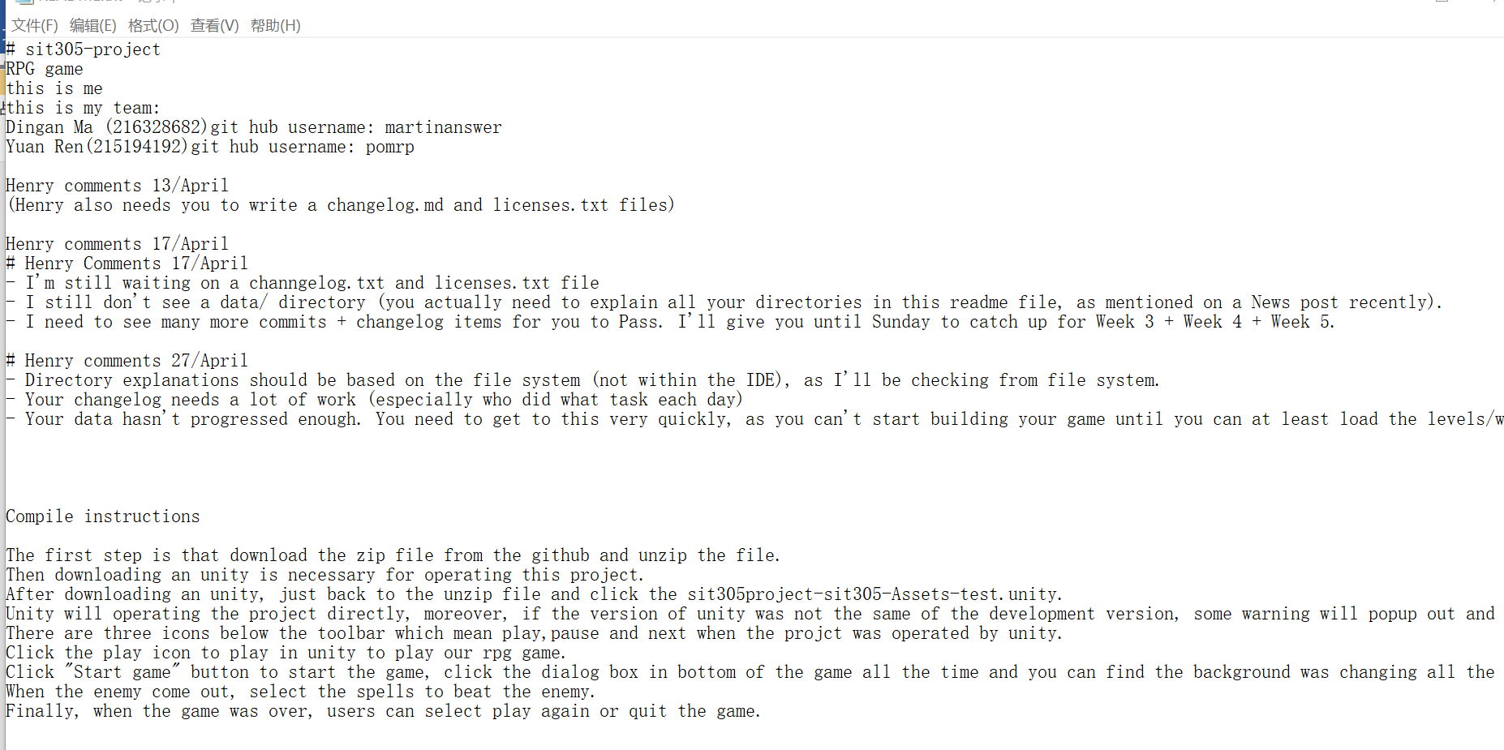

1. Includes an explanation of major features.

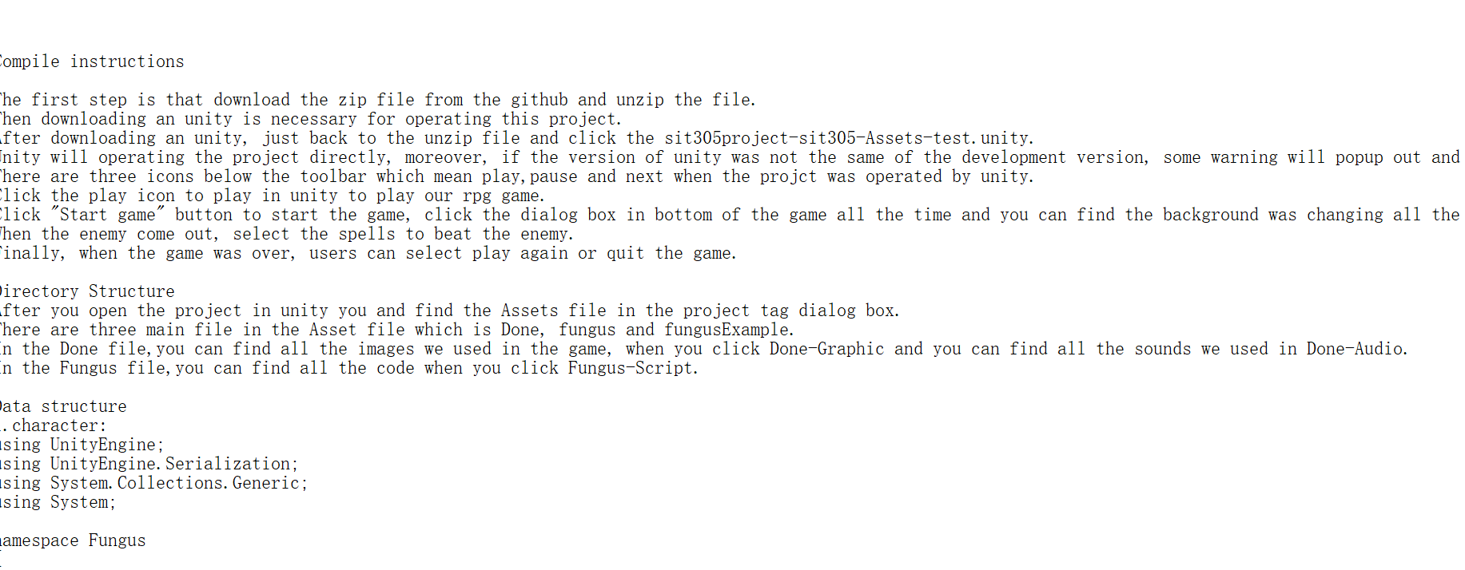

1. Includes an API reference of your major public classes / functions / methods, should others take over the project and wish to develop / use it further.

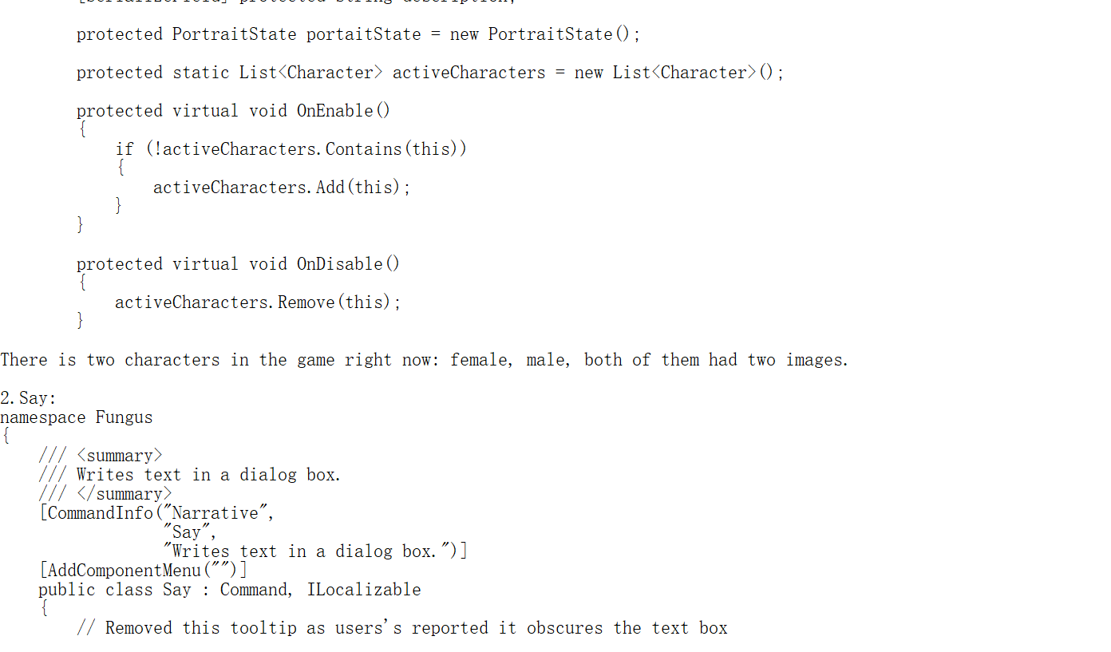

### Criteria: Licenses [HD]

1. [P] You have a licenses.txt / .xls file, and all materials you use you have legal rights to use for commercial use. -------Achieve
2. [C] You also have a Legal section / About page with Legal section, where you make all attributions you are legally required to. --------------------Achieve
3. [HD] Your attributions also include hyperlinks to source pages, as per author wishes. ---------Achieve

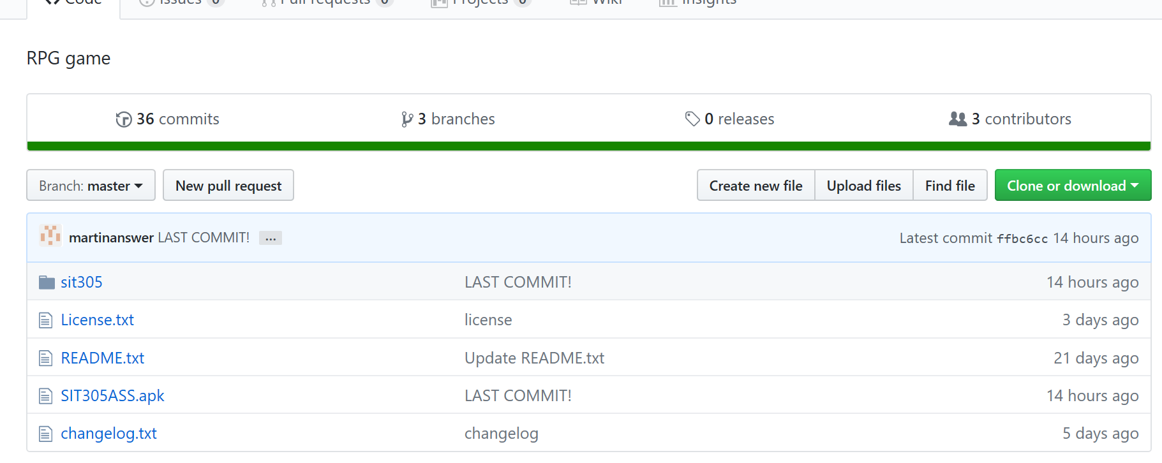

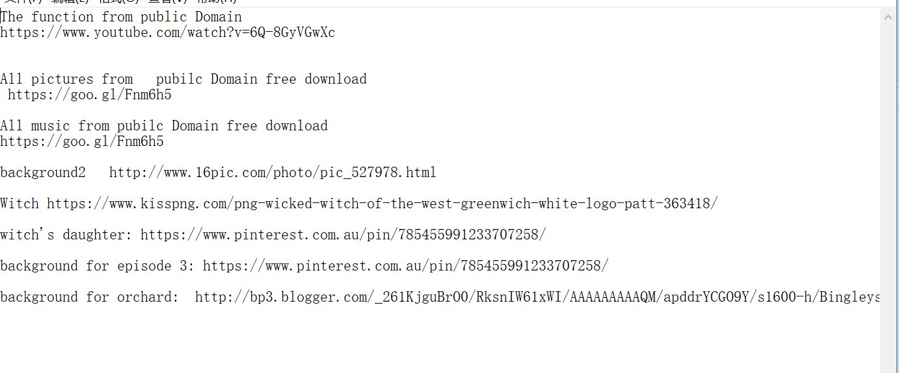

### Criteria: Weekly Progress [HD]

1. Changelog updated at least once a week (per person)

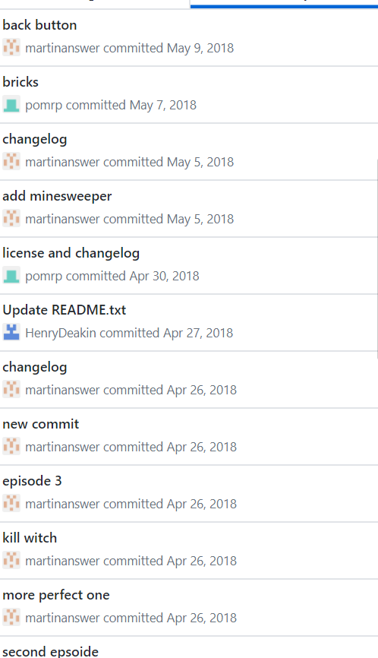

1. [C]Changelog lists all new major features added per day-of-work, and a list of “Still working on” for current features in progress……………….Achieve
2. [HD]You include, at the end of each work day, a summary of how you are progressing related to your milestones.

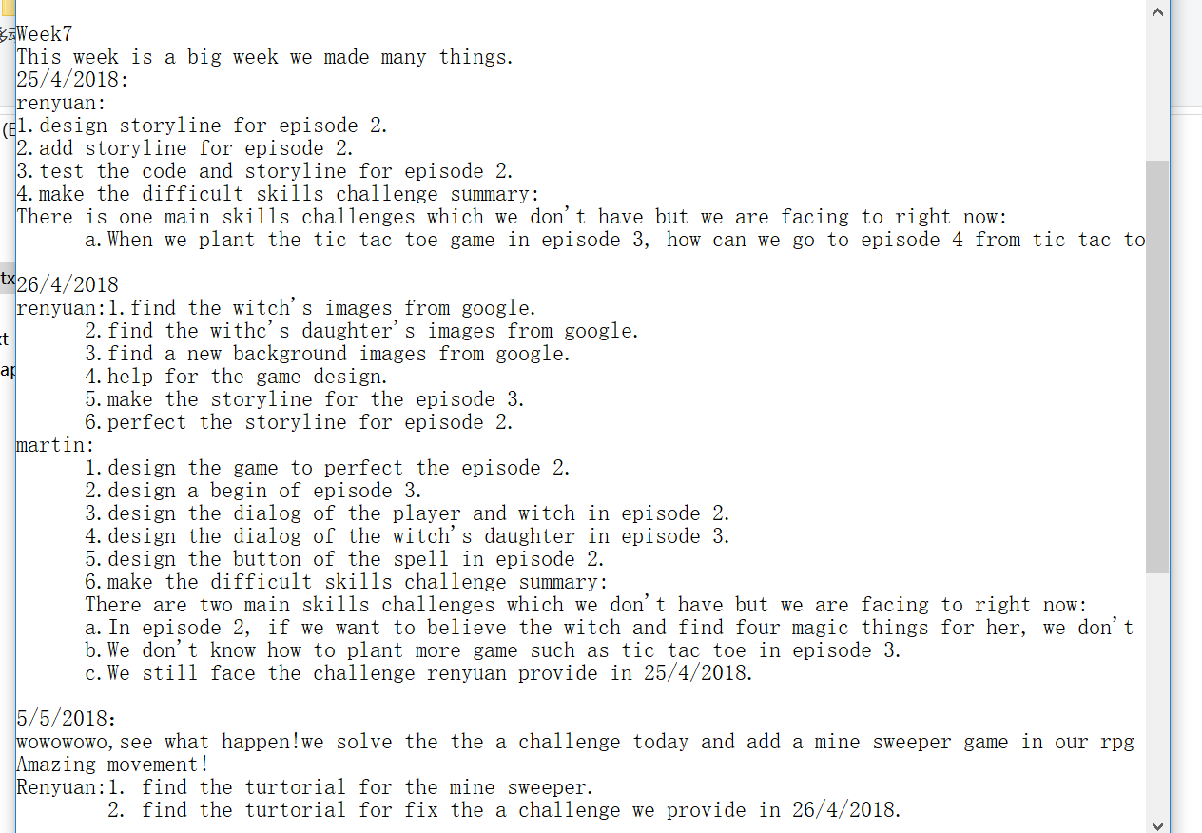

### Criteria: Data Handling [HD]

1. [P]You load all your game data through local text files.

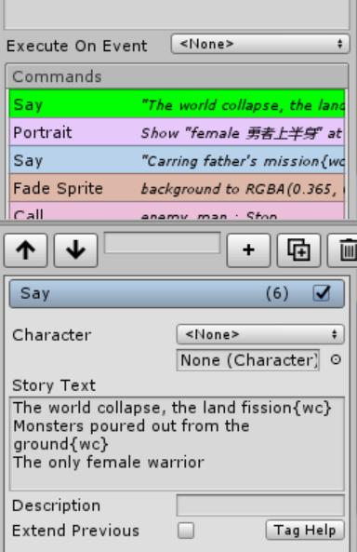

1. [C] You also have all app constants in local text files……………………….achieved
2. [D] You also load & save user settings to an external file / DB / resource.

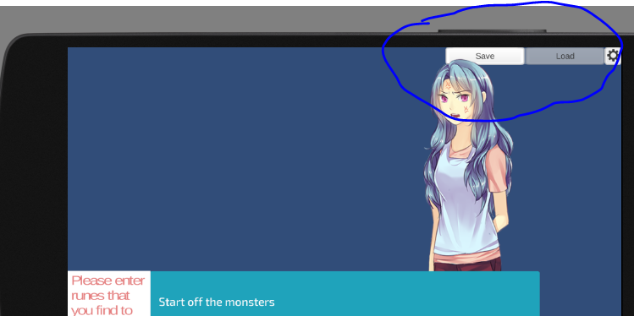

1. [HD] You also load & save user/player state from/to external file / DB / resource……..Achieved

### Criteria: Code Quality [HD]

1. [p]Indentation is perfect. Every class, and each major method/function has a brief comment……………………Achieved
2. [c] Every class, and each major method/function has an explanation comment, as well as method/function signature explanation………………………….Achieved
3. [hd] Each major method/function also has several examples of how to call it (where there are parameters), and snippet examples of returned data…………………………..Achieved

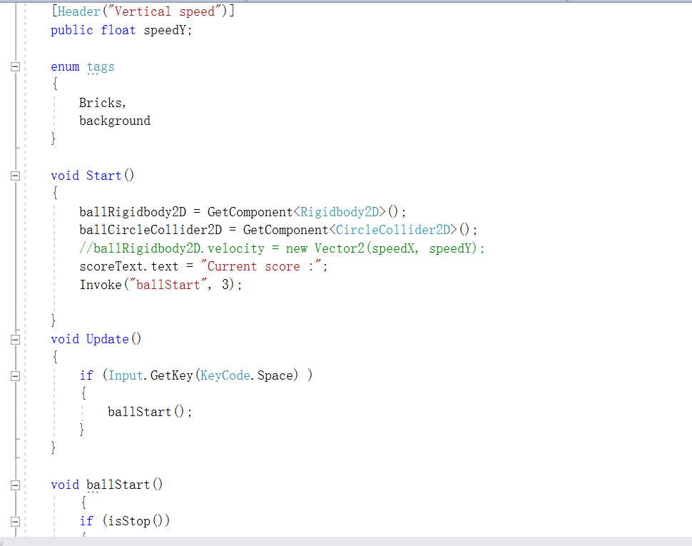

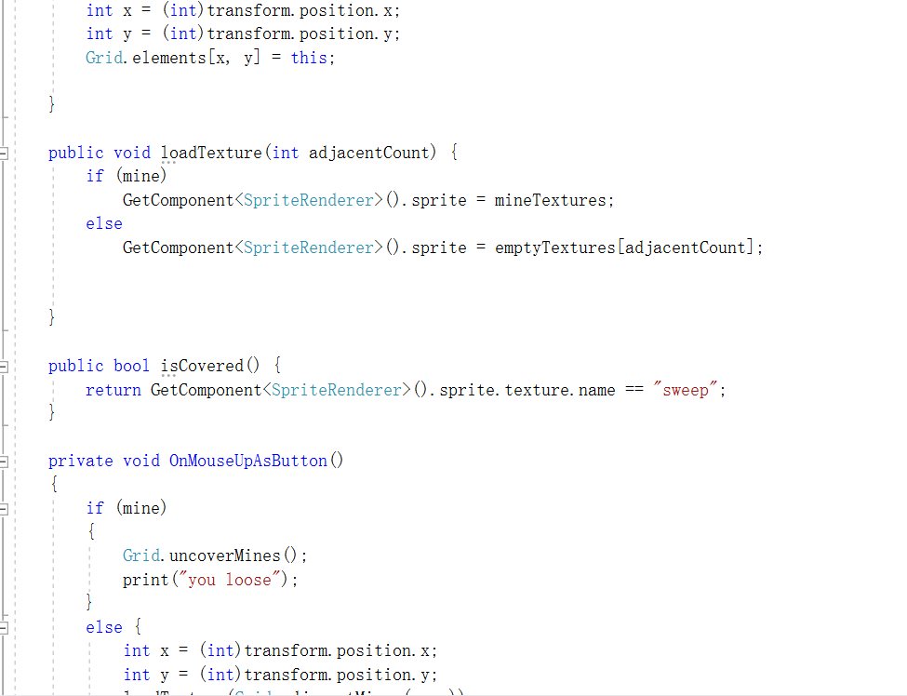

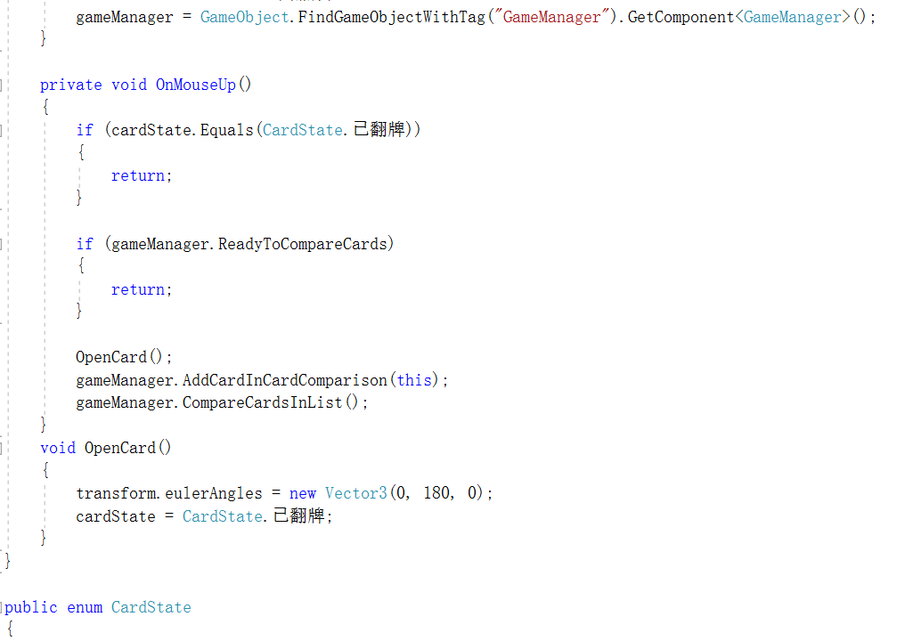

### Criteria: Bug Handling [HD]

1. [p]Your code gracefully handles all bugs, and restarts or resumes as appropriate.

Achieved

1. [c] Your code also keeps all data safe and saved, as well as captures and details and reports bugs to the end-user at a high level……………………Achieved
2. [hd] Your code also keeps a log page, that the end user can access, listing all bugs captured.

Achiieved

### Criteria: Data Size [HD]

Data Size>3KB

### Criteria: Publishing [Distinction]

1. [P] App would meet minimum App Store Guidelines……………………Achieved
2. [D] Your app has all icons and splash screens appropriate for the devices you are targeting……………………….Achieved